Cyber Bullying Detection Using Machine Learning Techniques

Dr. M. Sakthivel  Professor, Department of CSE  Sree Vidyanikethan Engineering College,  Tirupati, Andhra Pradesh, India | V. Nagesh  UG Scholar, Department of CSE  Sree Vidyanikethan Engineering College,  Tirupati, Andhra Pradesh, India | V.Ganga Pradeep,  UG Scholar, Department of CSE  Sree Vidyanikethan Engineering College,  Tirupati, Andhra Pradesh, India
V. Hemanth Kumar Reddy,  UG Scholar, Department of CSE  Sree Vidyanikethan Engineering College,  Tirupati, Andhra Pradesh, India | V. Sindhura  UG Scholar, Department of CSE  Sree Vidyanikethan Engineering College,  Tirupati, Andhra Pradesh, India | P. Chirudeep  UG Scholar, Department of CSE  Sree Vidyanikethan Engineering College,  Tirupati, Andhra Pradesh, India

I ABSTRACT

As cyberbullying has become increasingly common, there has been a lot of focus on cyberbullying detection because cyberbullying has a fatal effect on both users of social media platforms and society. Social media has become a channel for many people to communicate their opinions, knowledge, and so on. It would have been one of the best things if it had not become a tool for many people to exact revenge, manipulate others, or harass and humiliate others. As a result, we do not require a monitoring system to control the misbehavior and bullying that spreads through social networks, which has led to the development of this model to automate the identification of cyberbullying. Our main goal is to create a model that categorizes comments as positive or negative.

Keywords
Cyber Bullying, Sentiment Analysis, Personality Analysis.

II Introduction
Cyberbullying is just bullying or harassing others via various Social Media platforms. As the technological era has progressed, the use of social media platforms has skyrocketed, with more than half of the world's population now utilizing them. As its popularity has grown, a piece of news or other information can now be shared with others in seconds. This is now one of its most essential applications. However, some people took advantage of this and began to seek enjoyment from it. Cyberbullying has since begun and has grown significantly.
Cyberbullying is known as an unseen crime, and many victims have been tormented online through toxic comments. According to some data, as many as Cyberbullying has affected 50% of children. Victims of cyberbullying may endure a variety of consequences, including mental health concerns, poor academic performance, a desire to drop out, and even suicidal thinking. Despite the fact that many victims confront this, many of them go unrecognized due of social standing and other factors. Cyberbullying also taints a person's image. The false rumors disseminated about them harm their reputation. Approximately 8 out of 10 children are victims of various forms of cyberbullying.. Machine learning is used to detect cyberbullying by identifying and classifying instances of online harassment, abuse, and bullying. This technique often entails training a model on a large dataset of cyberbullying cases as well as non-cyberbullying text examples. The model can then be used to predict whether future occurrences of online text are likely to be cyberbullying. Personality Analysis, Sentiment Analysis, and User Traits are some of the factors that the algorithm takes into account while making these predictions. The purpose of this technique is to create a rapid, scalable, and automated mechanism to detect and solve cyberbullying, so that online communities can be safer and more supportive for everyone.
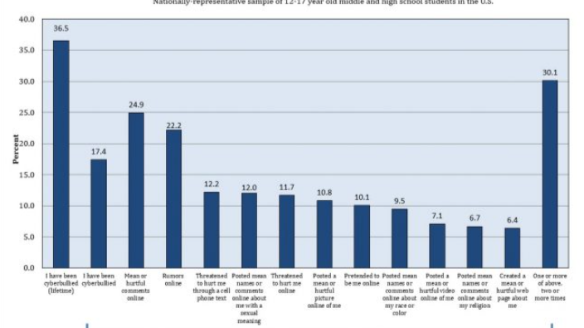

Fig.1.CyberBullying Victimization and Reasons

There have been numerous incidents of cyberbullying, ranging from a mother seeking vengeance for her child, which resulted in the suicide of a thirteen-year-old girl, to people tormenting others for the sake of pleasure.Initially, this was taken casually, and there were no rules governing it. However, it has grown swiftly, and many individuals are victims of it. Despite the fact that there are numerous laws in place to punish individuals who bully others. Despite this, the number of has never dropped. So we're opting for a preventative technique in which we'll employ a machine learning model to recognize phrases and sentences that are used to injure or harass people and then replace them with positive comments. Here, we'll apply the concept of ensemble algorithms to improve the model's accuracy.
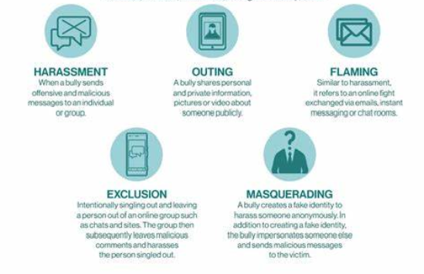

Fig.2.Types of CyberBullying

RESEARCH OBJECTIVES

1. We would be using various machine Learning Techniques to build a model that accurately identifies instances of cyberbullying.
2. To develop a model that Classifies the type of cyberbullying being used .Various types of cyberbullying being harassment, threats, spreading rumors, Flaming etc.
3. To train and test the model using the twitter dataset that is available online.
4. The dataset consists of both positive and negative contexts of cyberbullying.
5 .The primary objective is to reduce the rate of cyberbullying.
6. Optimize the performance of model using ensemble algorithms.

III SCOPE OF THE WORK

The system will employ the supervised learning methodology. The dataset will contain two sets of data, both good and negative in the context of cyberbullying. The proposed method will detect cyberbullying and convert negative remarks into good ones. We'll employ a variety of algorithms, including naive bayes, random forest, and decision tree learning.

IV PROBLEM STATEMENT

Cyberbullying is the use of numerous social media platforms to manipulate, torment, or harass another person, and it is a developing concern in today's technology day. With the increased use of social media and other online platforms, cyberbullying has increased significantly, causing a slew of serious issues in victims such as depression and inferiority complexes. Machine Learning has various sets of algorithms that are used to develop various types of predictive models. This has simplified many challenges, one of which is cyberbullying detection. Cyberbullying has become more common as the use of social media platforms has grown.

V LITERATURE SURVEY

Machine Learning contains several algorithms that are used to create various types of predictive models. This has simplified many challenges, one of which is cyberbullying detection. Cyberbullying has become more common as the use of social media platforms has grown. Because detecting cyberbullying involves a vast amount of data that is continually increasing, we require a model that recognizes the cyberbullying context in real time. It is possible to achieve this by utilizing machine learning techniques such as naive Bayes, Decision tree, and Random forest, as well as ensemble algorithms to optimize the model.

A RELATED WORK:

Andreas Weiler et al investigated the run-time and task-based performance of numerous Twitter event recognition algorithms. The writers took a two-pronged approach. The scientists gathered a dataset of cyberbullying-related tweets and developed a machine learning classifier to detect cyberbullying in real-time. To identify cyberbullying tweets, the classifier used a support vector machine (SVM) algorithm and a collection of variables such as sentiment analysis, frequency of abusive terms, and user mentions.

A study developed a method for detecting foul language that included a syntactic element and performed better than the standard learning-based method. (Chen, Zhou, Zhu, & Xu, 2012). In a YouTube data-based instance (Dadvar, Trieschnigg, Ordelman, & de Jong, 2013), SVM was used to detect cyberbullying, and it was discovered that integrating user-generated content boosted SVM detection accuracy. Dadvar et al. used MySpace data sets to create their findings.

Cynthia Van Hee and Gilles Jacobs suggested a strategy for automatic cyberbullying identification in social media text by modeling postings authored by bullies and victims using online bullying standards. Two corpora were created by gathering data from social networking sites such as Ask. fm. For pre-processing, a model was created that used tokenization, PoS-tagging, and lemmatization. To test language conversion and subsequent accuracy, models for English and Dutch were constructed. The accuracy of the ML algorithm SVM was 64% for the English language and 61% for the Dutch language.

Hannah L. Schacter et al investigated how cyberbullying victims' disclosures on Facebook influence bystanders' features of guilt, empathy, and ideas of intervening on behalf of a casualty following the completion of a cyberbullying incident. The researchers chose 118 participants at random to read the Facebook page of a cyber-victim who had posted an update with varied levels of personal disclosure and valence. (i.e., positive or negative tone).The study's findings revealed that participants who examined the high personal disclosure profile, regardless of valence, blamed the victim more and felt less empathy for the victim. As a result, the likelihood of bystander intervention in the bullying incidence was anticipated to be lower. According to the authors, this effect may be attributable to the victim's perceived responsibility and deservingness based on their level of personal exposure.

S.E.Vishwapriya, Ajay Gour, and colleagues [12] used machine learning to develop a model for detecting hate speech and objectionable language on Twitter. The datasets were obtained via crowdflower and GitHub. Tweets in the Crowdflower dataset featured categories like Hateful, Offensive, and Clean, whereas the GitHub dataset had columns like tweet id and class like sexism, racism, and neither. The tweet id was used to retrieve tweets from the Twitter API. These datasets were then joined together. Tweets were lowercased, and Space Pattern, URLs, Twitter Mentions, Retweet Symbols, and Stop words were removed. Stemming was used to minimize inflectional forms of words. After that, the dataset was divided into 70% training and 30% test samples. N-gram features from tweets were retrieved and weighted based on their TF IDF values. Unigram, Bigram, and Trigram characteristics, as well as L1 and L2 normalization of TF IDF, were taken into account.The algorithms of Logistic Regression, Nave Bayes, and Support Vector Machine were compared. Logistic Regression with L2 Normalization and n=3 yielded 95% accuracy.

Matthew Pittman and Brandon Reich performed a mixed-design survey to investigate whether text- and image-based social media sites like Twitter and Yik Yak, as well as platforms like Instagram and Snapchat, can help reduce loneliness by promoting more intimacy. Since young adults are the group most likely to use social media and experience loneliness, they were the focus of their study. Both quantitative and qualitative information from the survey was analyzed by the researchers. The quantitative findings revealed that as a result of using image-based social media, loneliness may diminish while happiness and life satisfaction may increase. Use of text-based media, in contrast, seemed ineffectual in this regard. The qualitative findings revealed that the increased intimacy provided by image-based social media use was what caused the observed impacts. Using image-based social media platforms reportedly increased participants' sense of community and sense of shared experience.
College students' experiences with various types of social media cyberbullying on social networking sites were the subject of a study by Kassandra Gahagan. (SNS). 196 undergraduate students from a Northwestern university participated in the study. The study's findings revealed that 46% of college students had seen cyberbullying on SNS and that 19% of them had experienced bullying on the platform. In addition, 61% of college students who saw cyberbullying on SNS took no action. The college students were asked about their experiences with cyberbullying as well as their perceptions of their responsibilities when they observed cyberbullying on SNS. Two distinct themes that arose from the responses were found by the study. Some college students thought their duty to step in depended on the circumstances, while others said there was a consistent, obvious level of obligation for college students who witnessed cyberbullying on SNS. According to the study's findings, college students frequently engage in cyberbullying on social networking sites, and bystander assistance is frequently missing. The report also emphasizes the necessity of bystander education and awareness efforts to encourage appropriate and proactive behavior in cases of cyberbullying.
The goal, according to H. Watanabe, M. Bouazizi, and T. Ohtsuki [10], was to find hate speech on Twitter. Their method is based on unigrams and automatically gathered patterns from the dataset. They wanted to categorize tweets as being "clean," "offensive," or "hateful." They employed three different kinds of datasets. The first dataset came from crowdflower, and it contains 14000 tweets that are categorized as clean, offensive, and hateful; the second dataset also came from crowdflower, and it contains tweets that are categorized as offensive, hateful, and neither; the third dataset comes from github, and it contains tweets that are categorized as sexist, racist, or neither. To create a larger dataset, they pooled 3 datasets. Along with removing the URL and tags from tweets during preparation, lemmatization, part of speech tagging, and tokenization were also performed.
Using machine learning and deep learning, Lida Ketsbaia, Biju Issac, et al. created a strategy to identify hateful and harmful tweets. The University of Maryland and Cornell Universities each produced a data set of around 35000 and 24000 tweets, with the labels "Hate" and "Non-Hate," respectively. Tweets were changed to lowercase, numerals, URLs, and user mentions were eliminated, stop words, punctuation, special characters, and contradictions were all swapped out. Next, the data set was balanced.In unigrams, bigrams, and trigrams, Bernoulli, Multinomial, and Logistic Regression classifiers were used. Accuracy was increased by using the Word2Vec method. For the datasets, accuracy of 95% and 96% was attained.

VI METHODOLOGY

We use various machine learning algorithms together to detect the context of cyberbullying .Here we will be using a supervised machine learning model as the dataset is of labeled data .The dataset has both the positive comments and negative comments .we will be using various algorithms like naïve bayes ,Random Forest and decision tree .Next we are going to combine all these using ensemble algorithms which are going to give us the optimized output .The performance also increases .Along the bunch of words here we would be concentrating on personality analysis .
The dataset is first collected, then divided into two halves. Training accounts for 75% of the time while testing accounts for 25%. Then, various machine learning techniques are used to build the model .Then this model is used to predict the context of cyberbullying.

A MODEL DESCRIPTION

Building a machine learning model to identify cyber bullying requires several steps:
Data Collection:
Collect a large and diverse dataset of text (such as social media posts or online comments) that contain instances of cyber bullying and noncyber bullying examples.
Data Preprocessing:
Clean the data by removing any irrelevant information, such as URLs, and perform any necessary text normalization, such as converting all text to lowercase.
Feature Engineering:
Decide on the features that the model will use to make its predictions. In the case of text classification, this usually involves creating numerical representations of the text, such as using term frequency-inverse document frequency (TF-IDF) or word embedding’s.
Model Selection:
Choose an appropriate machine learning algorithm for the task of text classification, such as a support vector machine (SVM), a neural network, or a random forest.
Model Training:
Train the model on the preprocessed and feature-engineered data. This involves providing the model with the features and corresponding labels (e.g., cyber bullying or non-cyber bullying) for each instance in the training data.
Model Evaluation:
Evaluate the performance of the model by testing it on a heldout test set and computing metrics such as accuracy, precision, recall, and F1 score.
Model Fine-tuning:
If necessary, fine-tune the model by adjusting its parameters or trying a different algorithm, and then repeat the evaluation step.

B Cyber bullying detection Model :
The cyberbullying detection framework consists of two key components, which are as follows:
1. Natural Language Processing (NLP)
2. Artificial Intelligence.
In the first phase, we pulled real-time tweets from Twitter, Whatsapp chats, and YouTube comments in English and Hinglish. Because this real-time data contains a number of superfluous characters, we must clean and prepare the data for detection before applying machine learning algorithms to it. We remove hashtags, stopwords, numeric data, hexadecimal patterns, and transform the text to lower case during the pre-processing stage. It is accomplished by utilizing numpy and vectorize routines. We manually compiled a list of stopwords in English and Hinglish and used it to delete them.
These terms should be removed from the clean data because their existence reduces the model's accuracy and predictions. We then used NLP techniques such as tokenization to break raw text into words known as tokens, lemmatization to reduce a given word to its core word, and vectorization to convert raw text into vectors or numbers.
Following pre-processing, we divided the dataset into two parts: training data and testing data. Following that, we used the two most significant text selection functions, which are:
1. Vectorizer of Counts
2. Inverse frequency (term frequency)

Based on the literature survey, we used various machine learning approaches such as Linear SVC, Decision Tree, Naive Bayes, Bagging classifier, Logistic Regression, Random Forest, MultinomailNB and K Neighbours Classifier, to train the model and determine the accuracy for each model in the second phase. We also calculated the F1 score for evaluation and enhanced accuracy by repeating the stages. We aimed to find the optimal combination of feature selection methods such as TF-IDF and count vectorizers and machine learning models. For this, we conducted a comparison of count vectorizer and TFIDF; based on this comparison, we identified the best pair with higher accuracy and shorter prediction time and created its pickle file. After that, we fed the testing data into the models to compare the accuracy of various algorithms. Following these stages, our model can predict whether the text entered is toxic, i.e. bullying and destructive to society, or non-toxic, i.e. non-bullying in English.

i. Data collection
Our data set includes text in English and Hinglish.
For the English data set, we grabbed real-time tweets from Twitter and also used a Kaggle dataset. The collection is made up of genuine tweets and messages obtained from various social media networking platforms. It has approximately 15,307

We extracted tweets from Twitter, WhatsApp chats, and YouTube comments for the Hinglish dataset. It has approximately 3000 rows. We then combined them to create a larger dataset. Tweets and Label are the two columns of the dataset. The label contains the numbers -1 and 0, which represent toxic (offensive) and non-toxic (non-offensive) statements, respectively. Our collection contains real-world samples of tweets and messages extracted from social media networking websites. It also has a broad variety of negative terms that are commonly used by people in their daily lives. This would assist us in detecting practically every unfavorable comment or tweet. The next step is to preprocess the data after it has been extracted. It is performed because real-world data contains a large number of superfluous characters, necessitating data cleaning in order to prepare the data for the detection phase. This is a time-consuming yet critical task.

ii. Data Preparation
Before running several ML models, the data must be cleaned, these steps must be deleted from the data because they do not contribute to the classification phase. When raw data from social networking sites is imported, it is collected with multiple characters and encoding.
We cleaned the data at this stage by deleting punctuation marks, special characters, retweet symbols, hashtags, numeric numbers, hexadecimal values, and URLs because they have no effect on the meaning of the statement. Words with fewer than three letters were deleted. To eliminate repetition, the sentences are also transformed to lowercase.
We also manually generated a list of stopwords for the English and Hinglish languages and used them to eliminate these words from the clean data because the existence of these unneeded words reduces the model's accuracy and predictions.

iii. Preprocessing Methodologies
We used natural language processing techniques after cleaning the data because the machine learning algorithm cannot work directly with raw text, that is, it cannot understand the entire sentences given to it, so we transformed these sentences into understandable format using preprocessing techniques. This was followed by three essential stages,
• Tokenization - Tokenization was applied to each phrase in the tweet. Tokenization is the act of dividing a text sequence into smaller parts, which include phrases, words, concepts, and symbols known as tokens.
• Lemmatization - Lemmatization comes after tokenization. This method is used to convert each word's inflectional forms into a root word.
• Vectorization - Finally, vectorization is an NLP methodology that assigns weight, i.e. probability, to each word in a document, which may then be used to find word predictions and semantics.
We divided the data into training and testing after cleaning it and performing pre-processing techniques.

iv. Data segmentation:
The datasets are classified into two types: training datasets and testing datasets. For the system to be used in real time, the testing datasets must be retrieved from the platforms via text mining. Both datasets are preprocessed and subjected to multiple ML models.

v. Feature choice:
We prepare the relevant text features after separating the data. This technique aids in determining the quality of the produced vector representations. This works with related words that tend to close with terms with varying degrees of resemblance. Vectorization is done before running the training and testing data sets through the ML models.
1) Count Vectorization: Vectorization is the process of converting a corpus of words into a vector of terms/term counts. The model will fit and learn the terms from the lexicon before attempting to create a word matrix in which the individual cells show the frequency of that word in a certain document, known as term frequency, and the columns are allocated to each word in the corpus.

2) TF-IDF: Term Frequency and Inverse Document Frequency is a scoring measure that determines how relevant a word is in a document. This is accomplished by multiplying two terms as follows:
i) The frequency of occurrence of a word in a document/text file.
ii) The word's inverse document frequency within a document/text file. It indicates how uncommon or common the word is in the document. If the value is close to zero, the word is more common, and vice versa.
The TF-IDF score of a word in the document can be calculated by multiplying these two terms. We conducted a comparison investigation of these two feature extraction techniques using a few algorithms and discovered that CV, or Count vectorizer, provides somewhat greater accuracy than TF-IDF. As a result, we chose TF-IDF as our feature selection model for predicting bullying texts, comments, conversations, and tweets in Hinglish and building machine learning models for classification.
Algorithms for Machine Learning
Following these preprocessing and feature selection stages, multiple machine learning models were evaluated and 8 machine learning models were identified to compare for functionality.
These models were chosen based on their popularity, ease of use, training time, and prediction time. The following are some of the classifiers utilized in the study:

1) SVM (Support Vector Machine): It is a classification method with the goal of fitting data and returning the best fitting hyperplane that categorizes or splits data into distinct classes. Some classifier features can predict class after acquiring a hyperplane. SVM selects extreme vectors or points to aid in the creation of hyperplanes known as support vectors. These vectors are closer to the hyperplane and have an effect on its orientation and position. There is no guarantee that all hyperplanes will perform well, which is why decision boundaries that are parallel to the hyperplane and touch a few supporting class vectors on one side of the hyperplane are developed. The margin is the distance between the two decision boundaries of the hyperplane, and it indicates a divider error. There is less categorization mistake when the margin is too wide. These points assist us in developing SVM models. SVM performs effectively with higher dimension data, avoiding dimensionality issues. It is also less prone to overfitting.

2) KNN (K Neighbors): The K-Nearest Neighbors (KNN) algorithm is a simple text classification technique that categorizes incoming data by comparing it to all available data using some similarity metric.
It generates classification rules in the form of a tree, where each internal node represents attribute conditions, each branch represents result conditions, and the leaf node represents the class label. Distance is employed in this approach to distinguish a fresh sample from its neighbors. Thus, it determines the K-nearest neighbors from the training set and assigns an item to the class that has the highest frequency of occurrence among its k nearest neighbors.

3) Logistic Regression: Logistic regression is a supervised machine learning approach that uses a set of independent factors to predict categorical dependent variables. It is a statistical strategy that allows us to quickly predict a data input based on past inspections of the data set in use. It may classify data as 0 or 1, Yes or No, true or false, and so on, but instead of providing exact numbers, it provides the likelihood that the provided data belongs to class '1'.

4) Decision Tree Classifier: In research, decision trees can be a useful approach for detecting cyberbullying. A decision tree is a form of supervised learning technique that may be used to categorize data into several groups. Decision trees can be used in cyber bullying detection to examine aspects of online content (such as text, photos, or videos) and classify them as instances of cyber bullying or non-cyber bullying. If the model's performance is inadequate, you may need to refine it by adjusting its settings or redefining its characteristics. This iterative procedure will assist you in developing a decision tree model that is successful at detecting cyberbullying.
Overall, decision trees can be a valuable technique for detecting cyberbullying in studies. Decision trees can help identify instances of cyberbullying and aid in the creation of effective intervention techniques by examining aspects of online content.

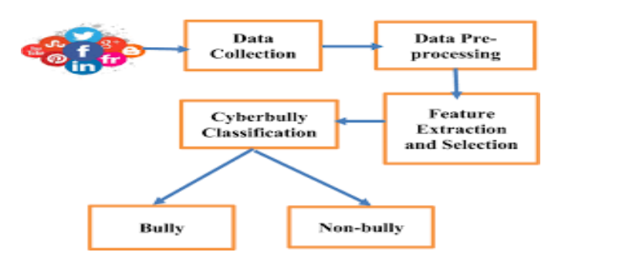

Fig.3.Model

Top 20 words used in cyberbullying tweets:
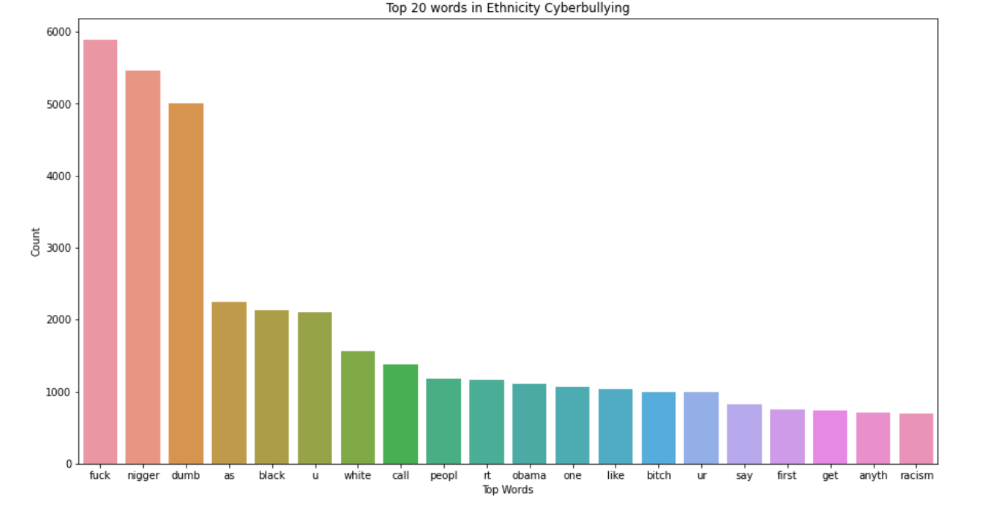

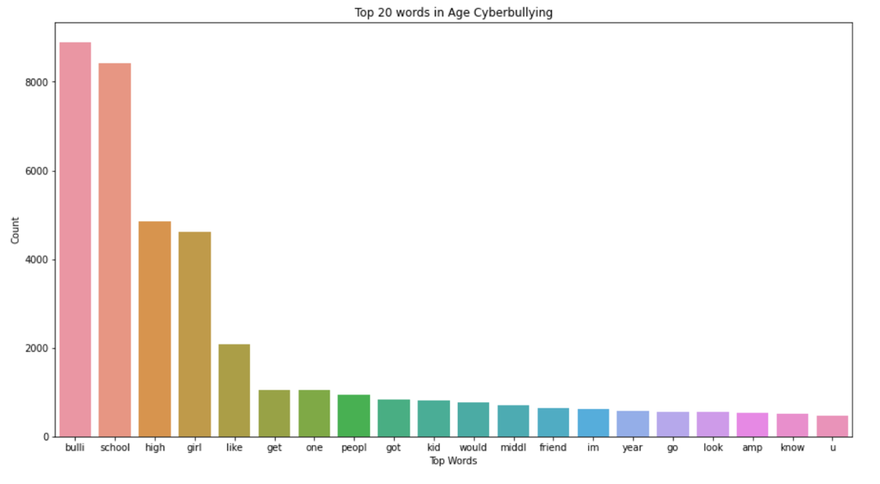

VII EXPERIMENTS AND RESULTS

IMPORTING LIBRARIES:

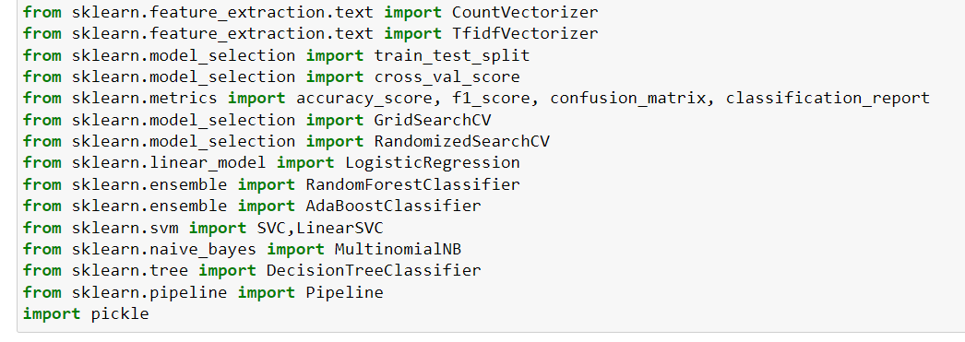

IMPORTING AND DOWNLOADING NLP TOOLS :

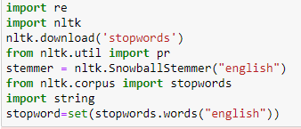

LOADING DATASET :
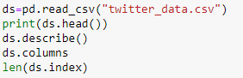

Here, we would be converting the target variable into a discrete variable as we would be working with decision tree classifier.

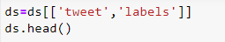
Here, we would be visualizing the changes we have made.

USER DEFINED FUNCTIONS:

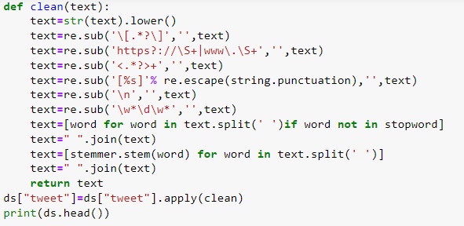
The inbuilt function clean is used to remove the unwanted gibberish or symbols from the tweets that are in the dataset.
Function to remove emoji’s in text:

SPLITTING THE DATASET:
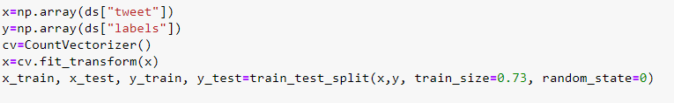

CREATION AND TRAINING OF DIFFERENT MODELS:

- Decision Tree Classifier
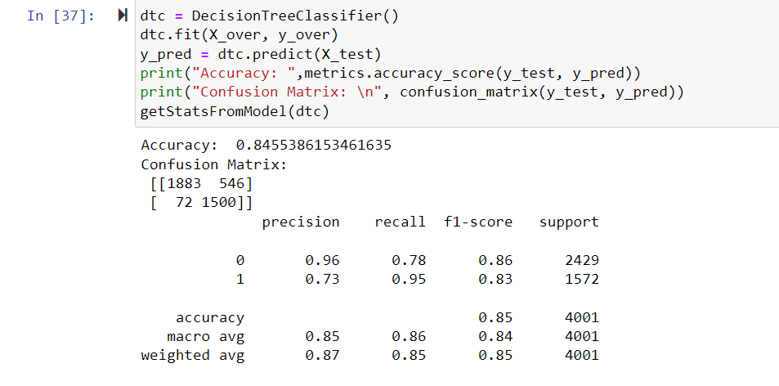
- Support Vector Machine
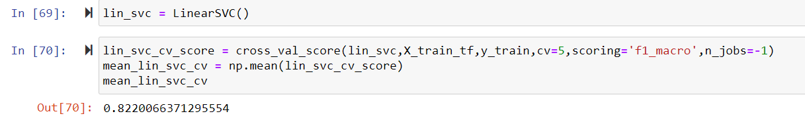
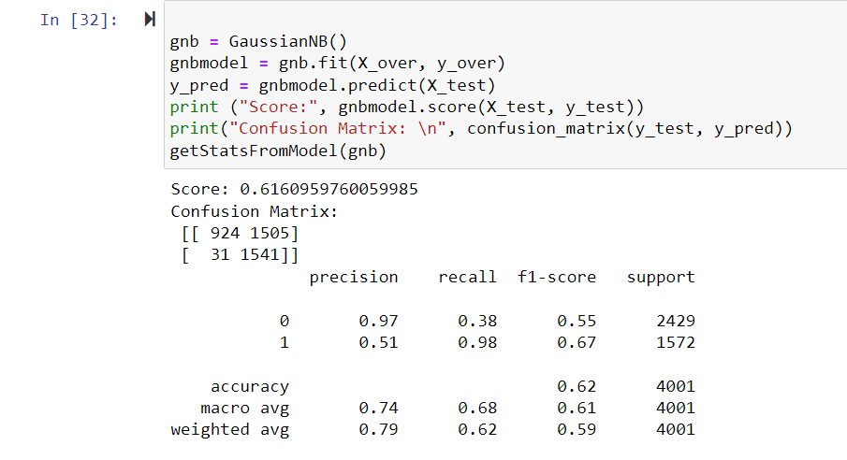
- Naïve Bayes
- Logistic Regression:
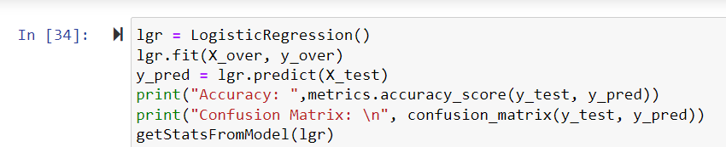
Logistic Regression Confusion matrix:
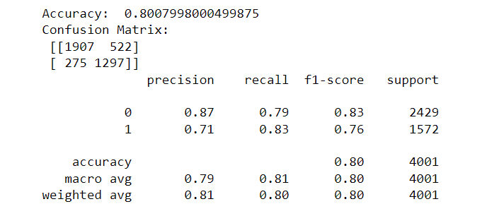
TESTING THE MODEL :

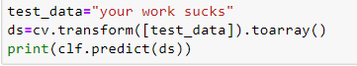

RESULT

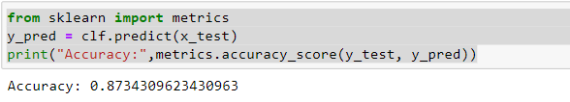

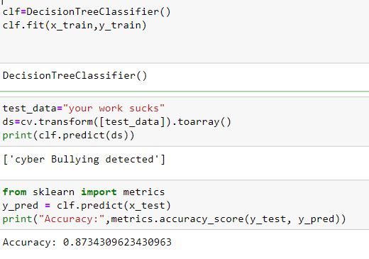

VIII CONCLUSION AND DISCUSSION

A. CHALLENGES FACED:
1) Long Execution time: Running all of the 450 experiments in the first set was challenging since it required a huge amount of time to complete. To overcome the slow execution time of the models, the experiments were conducted in parallel on high-performance compute nodes in Compute Canada clusters.
2) Random under sampling: The use of random under sampling had a negative effect on model’s performance. This can be due to the huge loss of information that happens when using this under sampling method. It is possible to experiment with over sampling techniques in the future to overcome this issue.

FUTURE WORK:

Along with the laws that are used to punish those people who cause cyber violence having an system that automatically detects the context of cyberbullying and changes it into a positive comment will be of great help as the saying goes prevention is the best .Using this will prevent lot of people from depression ,low self-esteem and also suicides.it also never let the users to use the social media as a tool to humiliate or bully others .The cyberbullying detecting system will lead to healthy environment on social media .It can be embedded into all social media and messaging apps.

IX REFERENCES

[1] B. Dean, “How many people use social media in 2021? (65+ statistics),” Sep 2021. [Online]. Available: https://backlinko.com/social-media-users
[2] J. W. Patchin, “Summary of our cyberbullying research (2004-2016),” Jul 2019. [Online]. Available: https://cyberbullying.org/summary-ofour-cyberbullying-research
[3] Noviantho, S. M. Isa, and L. Ashianti, “Cyberbullying classification using text mining,” in 2017 1st International Conference on Informatics and Computational Sciences (ICICoS), 2017, pp. 241–246.
[4] C. Van Hee, G. Jacobs, C. Emmery, B. Desmet, E. Lefever, B. Verhoeven, G. De Pauw, W. Daelemans, and V. Hoste, “Automatic detection of cyberbullying in social media text,” PloS one, vol. 13, no. 10, p. e0203794, 2018.
[5] M. A. Al-Garadi, M. R. Hussain, N. Khan, G. Murtaza, H. F. Nweke, I. Ali, G. Mujtaba, H. Chiroma, H. A. Khattak, and A. Gani, “Predicting cyberbullying on social media in the big data era using machine learning algorithms: Review of literature and open challenges,” IEEE Access, vol. 7, pp. 70 701–70 718, 2019.
[6] K. Sahay, H. S. Khaira, P. Kukreja, and N. Shukla, “Detecting cyberbullying and aggression in social commentary using nlp and machine learning,” International Journal of Engineering Technology Science and Research, vol. 5, no. 1, 2018.
[7] M. Di Capua, E. Di Nardo, and A. Petrosino, “Unsupervised cyber bullying detection in social networks,” in 2016 23rd International conference on pattern recognition (ICPR). IEEE, 2016, pp. 432–437.
[8] H. Hosseinmardi, S. A. Mattson, R. I. Rafiq, R. Han, Q. Lv, and S. Mishra, “Detection of cyberbullying incidents on the instagram social network,” arXiv preprint arXiv:1503.03909, 2015.
[9] V. Banerjee, J. Telavane, P. Gaikwad, and P. Vartak, “Detection of cyberbullying using deep neural network,” in 2019 5th International Conference on Advanced Computing & Communication Systems (ICACCS). IEEE, 2019, pp. 604–607.
[10] H. Watanabe, M. Bouazizi, and T. Ohtsuki, “Hate speech on twitter: A pragmatic approach to collect hateful and offensive expressions and perform hate speech detection,” IEEE access, vol. 6, pp. 13 825–13 835, 2018.

